H1 eth0 9000 MTU

H1 eth1 576MTU

MPTCP =1

Source 10.0.0.2

Source 10.0.1.2

Throughput

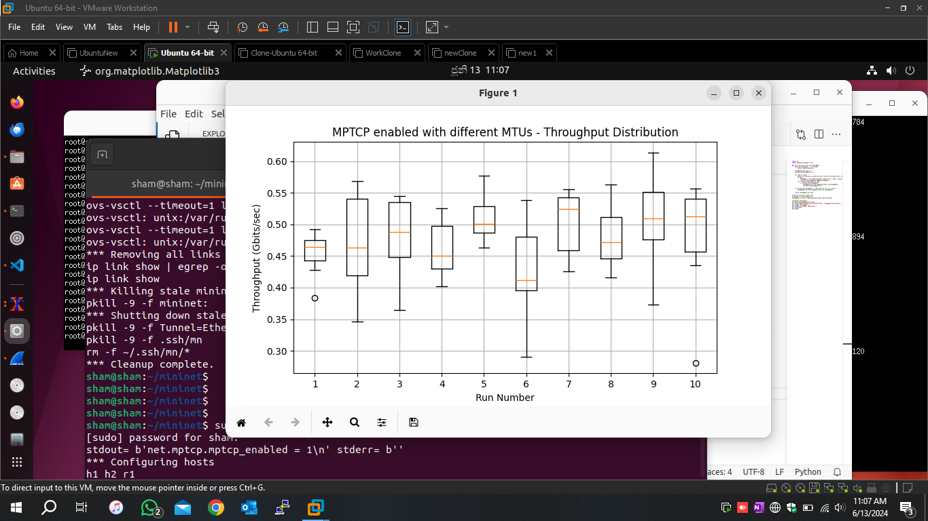

MPTCP=0

H1 eth0 9000 MTU

H1 eth1 576MTU

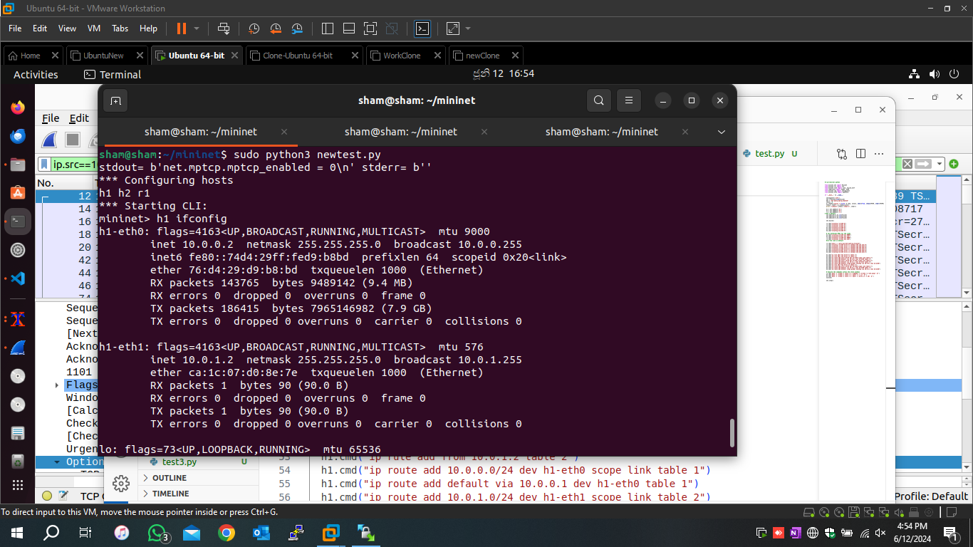

Source=10.0.0.2

source=10.0.1.2

Throughput

Throughput comparison

MPTCP=1

H1 eth0 = default MTU

H1 eth1 =default MTU

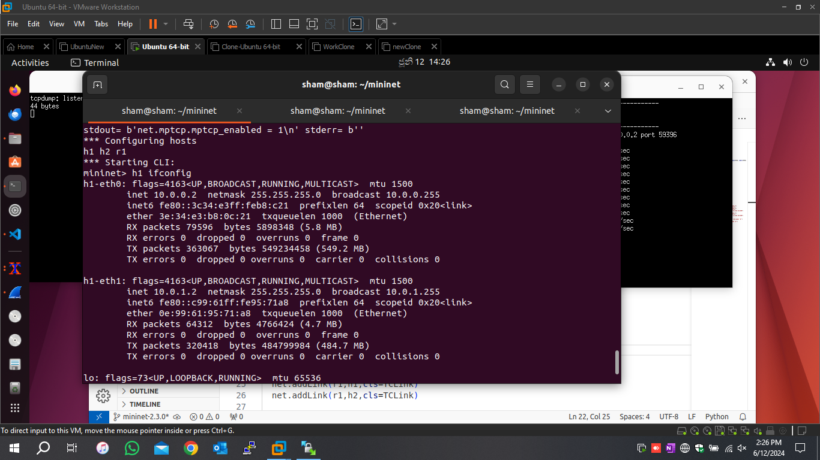

Source=10.0.0.2

Source= 10.0.1.2

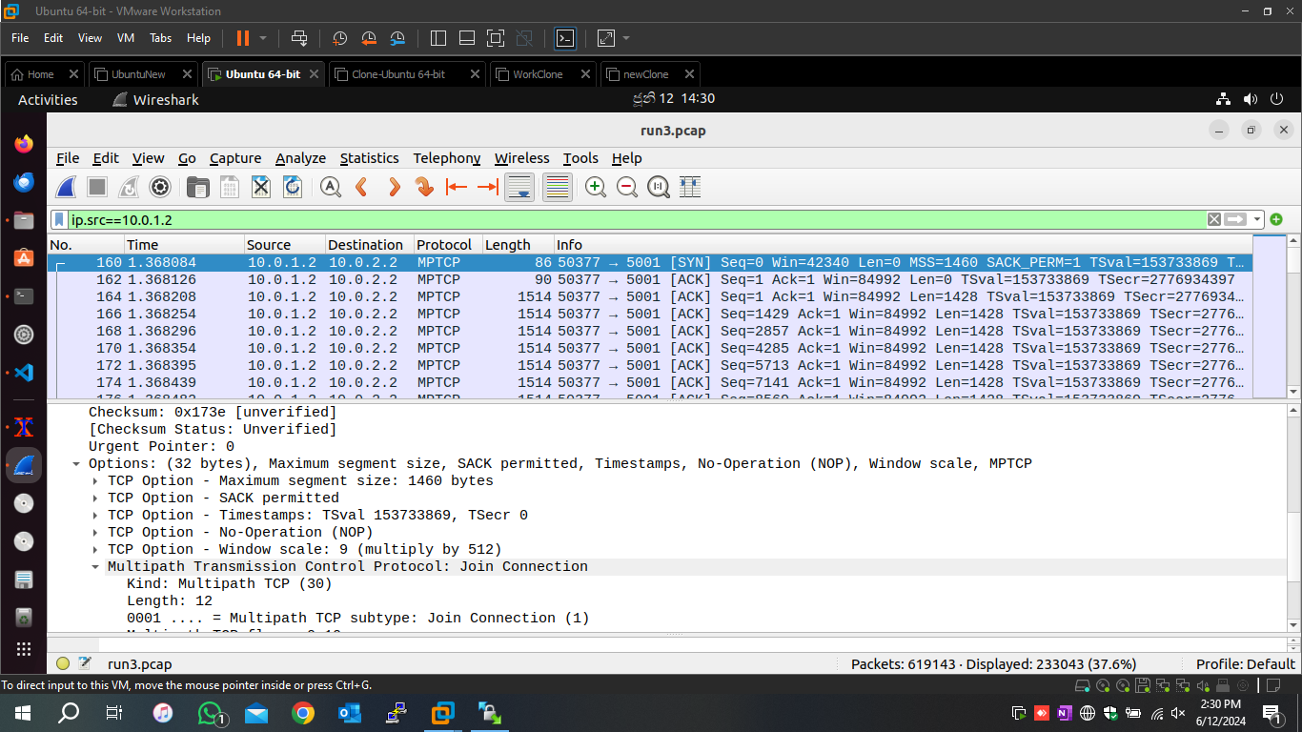

Throughput

MPTCP=0 default MTU (1500 for all)

MPTCP= 0 MTU 9000 all

MPTCP=0 MTU 576 all

MPTCP=1 default MTU (1500 for all)

MPTCP=1 MTU 9000 all

MPTCP=1 MTU 576 all

MPTCP=1 MTU 9000 and 576

MPTCP=0 MTU 9000 and 576

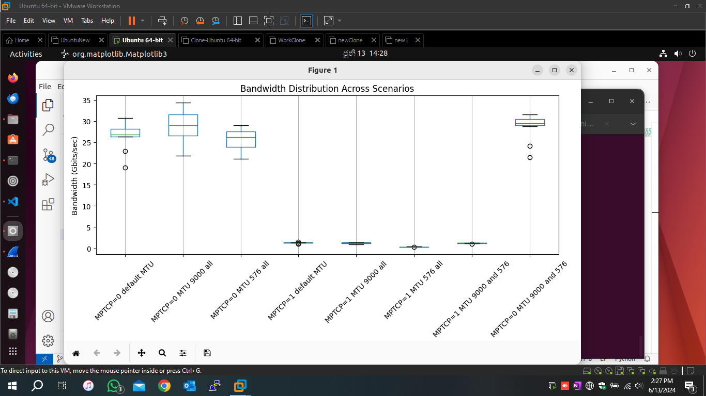

Drive link: [MPTCP](https://drive.google.com/drive/folders/1aBKDrZR7nvRdRnI-NcYn_8VjAarQBkOw?usp=sharing)